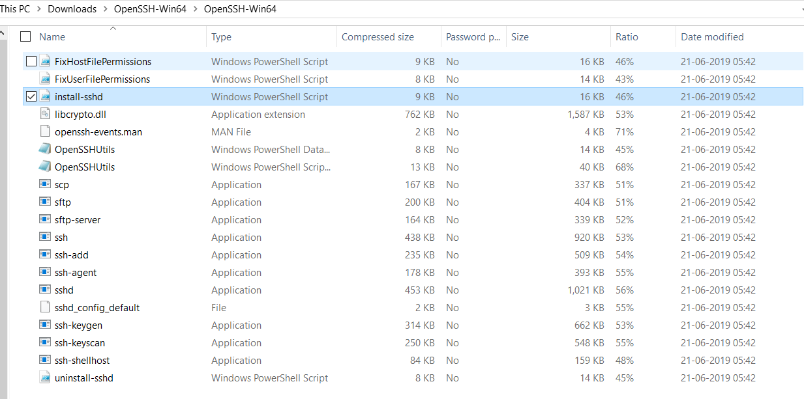

Run install-sshd powershell script to create new service for sshd , Then start sshd service using below command.

* Start-service sshd
* Use netstat command to check whether 22 port is listening.

**Use pscp command in below format for file copy operation**

pscp -pw yourPasswordHere C:\Users\testUser\Downloads\test.sh testUser@123.123.123.123:C:\Users\